Coinbook



Version 3.0.0.32

# test

## Inhalt

Kapitel 1 test 3

Inhalt 3

Kapitel 1 Allgemein 1-1

Beschreibung 1-1

Programminhalt 1-1

Unser Service 1-1

Systemanforderungen 1-1

Installation 1-2

Aktivierung 1-5

Bedienungsgrundlagen 1-7

Eingabe-/Anzeige-Elemente auf den Masken 1-10

Menüsystem 1-14

Kapitel 2 Masken 2-1

Hauptmaske 2-1

Weitere Funktionen in der Hauptmaske: 2-6

Münzendetails 2-18

Sammlungsmünzen und Dubletten erfassen 2-24

Sammlungsmünzen bzw. Dubletten löschen 2-26

Eigene Katalognummern bearbeiten 2-27

Eigene Preise bearbeiten 2-28

Eigene Bilder importieren. 2-30

Auktionen verwalten 2-32

Einstellungen 2-34

Kurse festlegen: 2-40

Münzprägeanstalten 2-41

Status der Datenbank 2-42

Datenbank verwalten 2-43

Import von CB2006 2-45

Import von Coinbook 2.x 2-46

Über das Programm 2-47

Handbuch (PDF) anzeigen 2-48

Aktuelle News laden 2-49

FAQ 2-50

Bestellung im Internet 2-51

Support 2-52

Gästebuch 2-53

Neue Module bestellen 2-54

Modul Updates einlesen 2-57

Updaten des Programms 2-59

Programmupdate von CD 2-61

Teamviewer 2-62

Spracheinstellungen 2-63

Bildschirmlupe 2-64

Ausgaben 2-66

Kapitel 3 Anhang 3-1

Datensicherung 3-2

Anleitung zum Import Ihrer Sammlung aus einer Vorversion. 3-5

Kapitel 4 Notizen 4-1

# Allgemein

## Description

Coinbook is Germany's first and only digital and modular coins - catalog with integrated collection and duplicate management..

## Program content

The program includes the following Areas:

* Collection coins capture, edit, delete
* Duplicates capture, edit, delete
* Capture of individual texts and auction data, detailed descriptions of coins
* Print collection, miscarriages, and Exchange lists
* Valuation of collection
* Rich imaging of coins, as well as the special editions

## Our service

* Semi-annual updates
* Support by mail
* Phone support
* Support via remote maintenance

## System requirements

* VGA graphics card or higher
* Hard drive with approximately 2 GB of free disk space (for full installation)
* mind. 1 GB RAM better and more
* any printer
* Operating systems: Microsoft® Windows® XP / Vista / Windows 7 / Windows 8 /. Windows 10

## Installation

The installation of Coinbook is relatively simple:

**Installation from the Internet:**

If you want to install Coinbook from the Internet, enter simply following address into your browser (Internet Explorer, Firefox, Opera, Google chrome, etc.) a:

[www.Coinbook.de/Downloads/Coinbook/CoinbookSetup.exe](https://ssl.translatoruser.net/bv.aspx?from=de&to=en&a=http%3A%2F%2Fwww.coinbook.de%2FDownloads%2FCoinbook%2FCoinbookSetup.exe)

(Please note here the exact upper and lowercase.)

To download the Setup program.

Then start please **CoinbookSetup.exe**

**Installation from CD:**

* If you want to install Coinbook from a CD, you just switch in your Explorer on the CD and start **CoinbookSetup.exe** there by double-clicking.

**CoinbookSetup:**

After starting the Setup program, the following window will appear.

Please confirm all window with the **Next** respectivley **Finish** button.

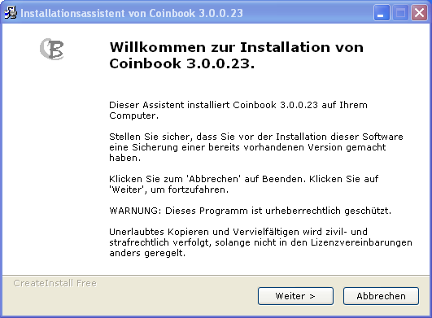

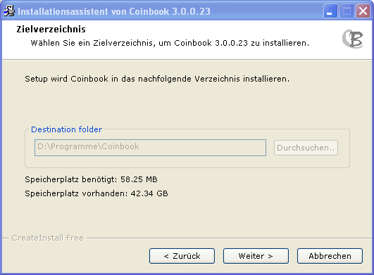

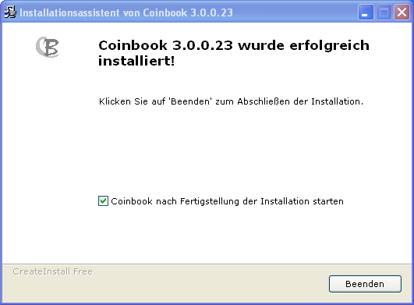

If Coinbook then start the first time, enter supplied license number which you via E-mail (or the CD version by stickers). Please note there may be upper and lowercase. You should also remember that occur only the letters a-f in the license number. actually, the 0 is the numeral 0.

‚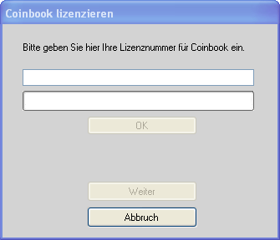

Press the button **OK**after entering the license number, and when the program tells you that the license right is the button **continue**.

The program will ask you then, if you want to enable Coinbook. See [***activation***](https://ssl.translatoruser.net/bv.aspx?from=de&to=en&a=https%3A%2F%2Fssl.translatoruser.net%2Fbvsandbox.aspx%3F%26dl%3Den%26from%3Dde%26to%3Den%23_Aktivierung) .

You should do that in the normal case, although you this process later via the menu (see [***Coinbook enable***](https://ssl.translatoruser.net/bv.aspx?from=de&to=en&a=https%3A%2F%2Fssl.translatoruser.net%2Fbvsandbox.aspx%3F%26dl%3Den%26from%3Dde%26to%3Den%23Aktivieren)) can get to.

Then read the modules is triggered automatically. See [***module updates***](https://ssl.translatoruser.net/bv.aspx?from=de&to=en&a=https%3A%2F%2Fssl.translatoruser.net%2Fbvsandbox.aspx%3F%26dl%3Den%26from%3Dde%26to%3Den%23_Modul_Updates_einlesen) **.**

## Activation

We must try to protect our program against piracy. This is done with the activation of the license.

Thus, it is possible to license per user, up to 3 PCs, notebooks and tablets for Coinbook.

This licensing is usually semi-automatic after installation. Coinbook asks immediately after the installation of the license, whether it should be enabled.

A further activation on this computer is

no longer necessary (also not in the updating of the modules)

You can use the program without activation for 30 days from the receipt of the software (not from the time of installation) in its entirety.

It makes sense to request this activation immediately after installation.

Should Coinbook not enabled until the end of this 30 days been be, Coinbook reports an invalid license. An activation can be done only through our support via E-mail or phone.

A new activation is also required if you are installing Coinbook on a new PC

Please contact our technical support so if the following problems occur:

* If a fault message of the program during activation
* If you want to install Coinbook on multiple computers.
* If you want to or have to lie to a new PC.

## Operation basics

The interface of the program is comprised of the following areas:

**Title bar**:

**F:\Titelzeile.png**

Here you will find the name of the program and the version number.

**Program control**

The program is controlled via the menu system or via the toolbar

**Menu**

F:\Menü.png

**Menu item file**

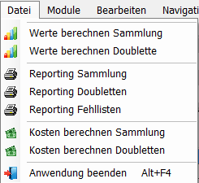

**Toolbar**:

**F:\Symbolleiste.png**

**Control using the keyboard**

The program is a Windows program. I.e. all functions can be operated with the mouse. There are however some functions which are controlled with the keyboard.

The following keys can be used:

|  |  |
| --- | --- |
| Cursor up and down | This function is available only in columns with input fields. So that is the cursor in the tables in this or including this input field is set |
| Tab and enter key | Hereby the next input or selection box in the table row is selected in the tables list. No further input field, located here then is the first field in the next line jumped to. |
| Cursor left and right | Works only within an input field.  Move the cursor within the text left or right |
| Pos1 and end | Works only within an input field.  Moves the cursor to the beginning or the end of the text in the box |
| Remove | Works only within an input field.  Removes the character to the right of the cursor |
| BACKSPACE | Works only within an input field.  Removes the character to the left of the cursor |
| CTRL + right arrow | Works only within an input field.  Move the cursor within the text by Word to the right. |
| CTRL + cursor left | Works only within an input field.  Moves the cursor within the text by Word to the left. |
| CTRL + SHIFT + right arrow | Works only within an input field.  Move the cursor within the text by Word to the right and marked at the same time |
| CTRL + SHIFT + left arrow | Works only within an input field.  Move the cursor within the text by Word to the left and marked at the same time |
| Pos1 + shift | Works only within an input field.  Moves the cursor to the beginning of the text in the box and these marks from the old cursor position |
| End + shift | Works only within an input field.  Moves the cursor to the end of the text in the box and these marks from the old cursor position |
| ALT + F4 | Closes the current window. If only the maintfenster of the program exists, is the program terminated. |

## Input / display elements on the layer masks

**Overview table**

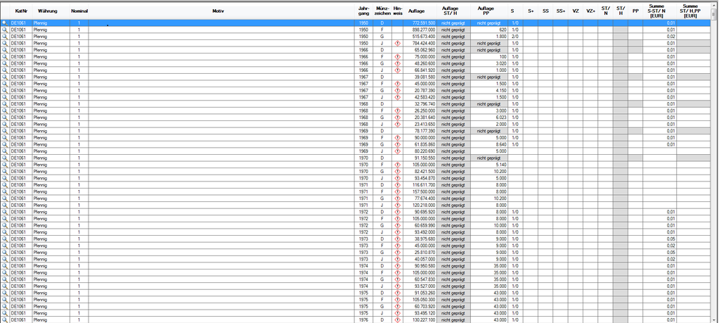

In a summary table, records are typically displayed to choose. These records cannot be modified in the table.

**Tab**

**F:\Tabreiter.png**

Tabs are used to represent different data in a mask on the same level.

By clicking on a tab tab you appear to data below.

**Input fields**



Input fields are used to display and collect any data. Input fields can verify that the button by the user is allowed here or not.

If you have for example a number field, you can enter any letters in this field. The field will not respond to the button.

If you have a field in which, for example, a sum of money to be entered, then a decimal point is automatically from the decimal point. You can enter only a comma, a second is simply not accepted. Also, you can enter no more decimal places than are defined in the field, etc.

There are also fields that although check the input, but to allow input.

For example, a field in the an E M ail address should be entered. Here, it is checked whether the entry matches the spelling of an E-mail address (it is possible will not check whether the address exists). Here, only the box is red deposited, if the content is not the spelling of an E-mail address.

**Option fields**

F:\Option.png

RadioButtons are used one of several ways to select. You can only click on a radio button. Then, the above point is displayed in it. If a different radio button in the Group was selected, the marking in this field is switched off.

**Buttons**



Buttons are buttons that can be pressed to perform certain functions.

**Check boxes**

F:\Checkbox.png

**Selection fields**



If you click on the arrow on the right side, a list of choices appears. Here you can choose exactly.

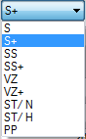

**Date fields**



Here you can enter your date in different ways:

Manual entry:

Double click on the day and entering the date of the day

Double click on the month and input of the month

Double click on the year and entry of the year

Selection in the calendar:

A monthly calendar of the current month is opened by clicking the arrow down. Here, you can then click the day.

In addition you can even months using the arrows or scroll down.

The same is true also for the year.

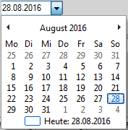

## Menu system

1. **File**



The menu item ***file*** , see CSV, PDF, Excel and Word complete statistics of the program as a screen and printer output and export to.

See [***Expenditure***](https://ssl.translatoruser.net/bv.aspx?from=de&to=en&a=https%3A%2F%2Fssl.translatoruser.net%2Fbvsandbox.aspx%3F%26dl%3Den%26from%3Dde%26to%3Den%23_Ausgaben) .

There is also the menu item, to end Coinbook

1. **Modules**

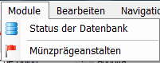

The menu module contains the status of the database (see [***State of the database***](https://ssl.translatoruser.net/bv.aspx?from=de&to=en&a=https%3A%2F%2Fssl.translatoruser.net%2Fbvsandbox.aspx%3F%26dl%3Den%26from%3Dde%26to%3Den%23_Status_der_Datenbank)), as well as an overview of the mints (see [***mints*** )](https://ssl.translatoruser.net/bv.aspx?from=de&to=en&a=https%3A%2F%2Fssl.translatoruser.net%2Fbvsandbox.aspx%3F%26dl%3Den%26from%3Dde%26to%3Den%23_M%C3%BCnzpr%C3%A4geanstalten) ).

**Edit**

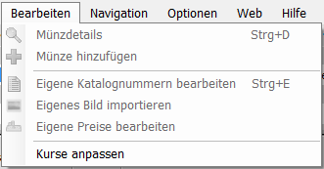

Here, you can perform various functions for marked in the overview table.

1. **Navigation**

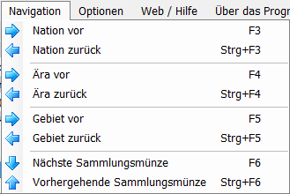

Here you can navigate in the overview table (see ***navigating*** ).

1. **Options**

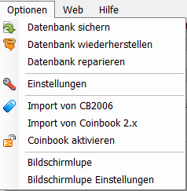

The menu item ***Options*** is used to manage the database ***(***[***database back up, restore and repair***](https://ssl.translatoruser.net/bv.aspx?from=de&to=en&a=https%3A%2F%2Fssl.translatoruser.net%2Fbvsandbox.aspx%3F%26dl%3Den%26from%3Dde%26to%3Den%23_Datenbank_verwalten) )***)***

You will also find here some basic settings of Coinbook (see [***settings***](https://ssl.translatoruser.net/bv.aspx?from=de&to=en&a=https%3A%2F%2Fssl.translatoruser.net%2Fbvsandbox.aspx%3F%26dl%3Den%26from%3Dde%26to%3Den%23_Einstellungen) ))

If you are upgrading from a previous version on Coinbook 3.x, you can import your collection data from the previous versions here after you reinstall of the current version.

See [***Importing CB2006***](https://ssl.translatoruser.net/bv.aspx?from=de&to=en&a=https%3A%2F%2Fssl.translatoruser.net%2Fbvsandbox.aspx%3F%26dl%3Den%26from%3Dde%26to%3Den%23_Import_von_CB2006) and [***Import from Coinbook 2.x***](https://ssl.translatoruser.net/bv.aspx?from=de&to=en&a=https%3A%2F%2Fssl.translatoruser.net%2Fbvsandbox.aspx%3F%26dl%3Den%26from%3Dde%26to%3Den%23_Import_von_Coinbook)

To of Lastly you can activate, if Coinbook has not been activated during the installation you here on ***Coinbook enable*** this. See [***activation***](https://ssl.translatoruser.net/bv.aspx?from=de&to=en&a=https%3A%2F%2Fssl.translatoruser.net%2Fbvsandbox.aspx%3F%26dl%3Den%26from%3Dde%26to%3Den%23_Aktivierung)

There is a so-called screen magnifier version 3.0.0.32 for Coinbooknutzer with bad eyes. So, you can see a magnified view of the region of the screen where the cursor is located, in a selected area of the screen. Here, you can turn this Magnifier and turn off, and set various key data.

1. **Web**

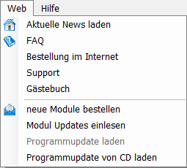

In the menu item [***Download latest news***](https://ssl.translatoruser.net/bv.aspx?from=de&to=en&a=https%3A%2F%2Fssl.translatoruser.net%2Fbvsandbox.aspx%3F%26dl%3Den%26from%3Dde%26to%3Den%23_Aktuelle_News_laden) you can display the latest news about Coinbook on our Web site, without having to go through your browser

[***FAQ***](https://ssl.translatoruser.net/bv.aspx?from=de&to=en&a=https%3A%2F%2Fssl.translatoruser.net%2Fbvsandbox.aspx%3F%26dl%3Den%26from%3Dde%26to%3Den%23_FAQ) shows you the FAQs on our Web site.

About [***Order on the Internet***](https://ssl.translatoruser.net/bv.aspx?from=de&to=en&a=https%3A%2F%2Fssl.translatoruser.net%2Fbvsandbox.aspx%3F%26dl%3Den%26from%3Dde%26to%3Den%23_Bestellung_im_Internet) reach the ordering on our Web page.

The menu item [***Support***](https://ssl.translatoruser.net/bv.aspx?from=de&to=en&a=https%3A%2F%2Fssl.translatoruser.net%2Fbvsandbox.aspx%3F%26dl%3Den%26from%3Dde%26to%3Den%23_Support) takes you to our technical support.

In the point [***Guestbook***](https://ssl.translatoruser.net/bv.aspx?from=de&to=en&a=https%3A%2F%2Fssl.translatoruser.net%2Fbvsandbox.aspx%3F%26dl%3Den%26from%3Dde%26to%3Den%23_G%C3%A4stebuch) you can reach our guestbook. If you are satisfied with our product and service, make a nice entry here.

Among [***order new modules***](https://ssl.translatoruser.net/bv.aspx?from=de&to=en&a=https%3A%2F%2Fssl.translatoruser.net%2Fbvsandbox.aspx%3F%26dl%3Den%26from%3Dde%26to%3Den%23_Neue_Module_bestellen) new modules, and updates of your modules can be ordered directly through the program.

Among [***Rescan module updates***](https://ssl.translatoruser.net/bv.aspx?from=de&to=en&a=https%3A%2F%2Fssl.translatoruser.net%2Fbvsandbox.aspx%3F%26dl%3Den%26from%3Dde%26to%3Den%23_Modul_Updates_einlesen) you receive your purchased modules online.

The point [***Program update***](https://ssl.translatoruser.net/bv.aspx?from=de&to=en&a=https%3A%2F%2Fssl.translatoruser.net%2Fbvsandbox.aspx%3F%26dl%3Den%26from%3Dde%26to%3Den%23_Updaten_des_Programms) will be active as soon as a new update of the programme is available and is installing a new program update.

At [***Program update from CD***](https://ssl.translatoruser.net/bv.aspx?from=de&to=en&a=https%3A%2F%2Fssl.translatoruser.net%2Fbvsandbox.aspx%3F%26dl%3Den%26from%3Dde%26to%3Den%23_Programmupdate_von_CD) can updates that you order a CD, install.

This point can only be used if you have no Internet access, or the PC you use to perform Coinbook is not connected to the Internet.

Please contact in this case with our support.

1. **Help**

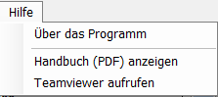

***About the program***

Some information about the program.

See [***About the program***](https://ssl.translatoruser.net/bv.aspx?from=de&to=en&a=https%3A%2F%2Fssl.translatoruser.net%2Fbvsandbox.aspx%3F%26dl%3Den%26from%3Dde%26to%3Den%23_%C3%9Cber_das_Programm) .

You can have the menu ***display manual (PDF)*** viewing this guide

[***TeamViewer call***](https://ssl.translatoruser.net/bv.aspx?from=de&to=en&a=https%3A%2F%2Fssl.translatoruser.net%2Fbvsandbox.aspx%3F%26dl%3Den%26from%3Dde%26to%3Den%23_Teamviewer) starts the supplied TeamViewer support sessions over the Internet.

# Masks

## Main screen

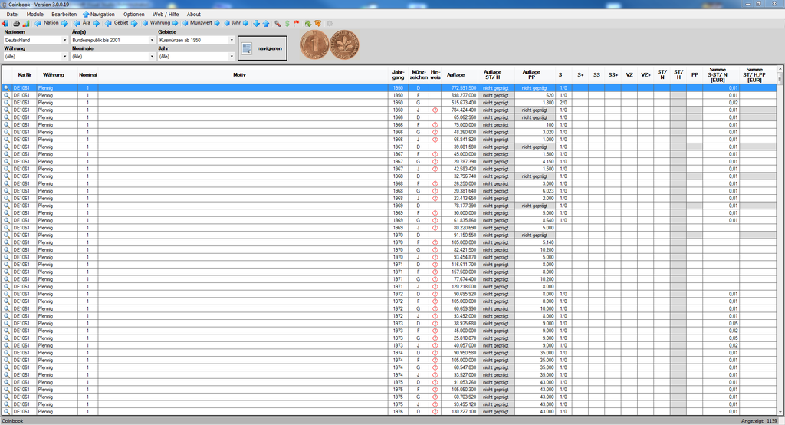

The core of the whole programme is the main mask.

Here am t the main menu, with which you can call up a large part of the masks.

Furthermore you will find here the navigation pane to display the coins in the overview table and a toolbar for fast driving.

Let's start here with the navigation pane:

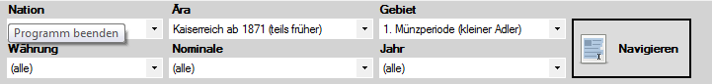

Enter the selection of ***Nations*** , they see all the modules that you have purchased when clicking on the arrow. If you then select one of these modules, the selection box is loaded ***era*** with the eras available in the selected nation or the selected module. The program then selects the first available era by itself and then populates the selection box ***Areas*** with regions available for this era.

When selecting an era the same for the selected era happens here in the fields.

This selection is already sufficient to display the corresponding coin. Then click ***Browse***button. You will receive listed all in the appropriate area existing coins.

Through the additional choice of ***currency***, ***nominal*** and ***year*** you are able to restrict the display additionally.

The toolbar allows you to quickly navigate in the overview table:

F:\Symbolleiste Navigation.png

|  |  |
| --- | --- |
|  | A nation scrolls, or back.  The operation corresponds to the selection in the combo box Nations |
|  | An era scrolls, or back.  The operation corresponds to the selection in the combo box eras |
|  | An area scrolls, or back.  The operation corresponds to the selection in the combo box areas |
|  | A currency scrolls, or back.  The operation corresponds to the selection in the combo box currency |
|  | A nominal scrolls forward, or back.  The operation corresponds to the selection in the combo box nominal |
|  | Scrolls a year ago, respectively.  The operation corresponds to the selection from a combo box year |
|  | Flip a coin down. |
|  | Flip a coin to the top |

In the toolbar perform these functions also via the Navigation menu:



You can also use the as stored in the menus, keys of function.

In the table you will find the ***details*** button links in the first column .

By clicking on this button, you call the detailed mask of the selected coin. This detail window displays all details of the coin, and here you can manage your collection and your duplicates.

This mask can also by marking the desired table row and subsequent menu selection Edit > coins details to be called:

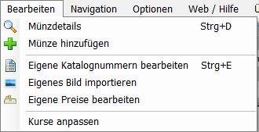

Some coins, visit the following character in the column Note: .

Special notes for this coin you will find there. By clicking on the sign, then following screen will appear:

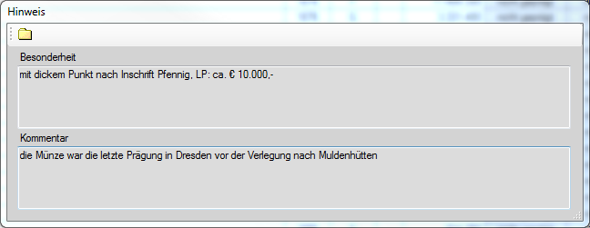

When selecting a coin (blue marking in the overview table) navigating is up next to the button if it exists that shows image of the coin that is marked in the table:

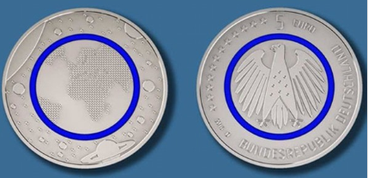

When you click this image with the mouse, an enlarged view of the coin will be shown.

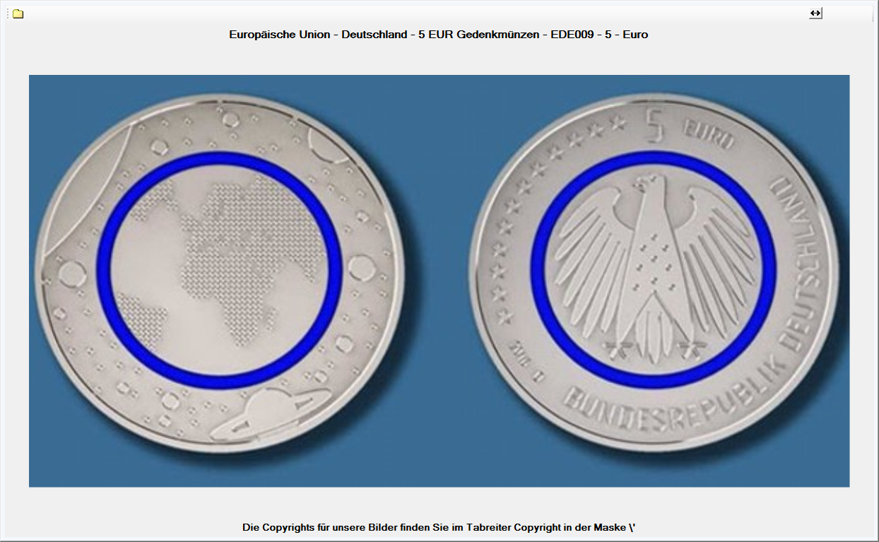

## Other functions in the main screen:

|  |  |  |
| --- | --- | --- |
| Symbol-leiste | Menü | Funktion |
|  | F:\Menu-Datei.png | Close the Program |
|  | F:\Menu-Datei.png | Reporting |
|  | F:\Menu-Datei.png | Value |
|  | F:\Menu-Datei.png | Calculate costs |
|  | F:\Menu-Module.png | Display the coin mints |
|  | F:\Menu-Module.png | State oft he database |
|  | F:\Menu-Navigation.png | Navigate |
|  |  | *Baxckup your collection* |
|  |  | Restoration of copllection data |
|  |  | repair database |
|  |  | Settings |
|  |  | Import data from Coinbook Version 2006 |
|  |  | Import data from Coinbook Version 2.x |
|  |  | Activate the Coinbook-Version |
|  |  | Switch on/off magnifier |
|  |  | Magnifier settings |
|  | **Menu-Bearbeiten** | Coin details  (Zeile der Münze blau markieren und dann den Menüpunkt anklicken) |
|  | **Menu-Bearbeiten** | add coin  (Zeile der Münze blau markieren und dann den Menüpunkt anklicken) |
|  | **Menu-Bearbeiten** | edit your on catalogue number  (Zeile der Münze blau markieren und dann den Menüpunkt anklicken) |
|  | **Menu-Bearbeiten** | import your own picture  (Zeile der Münze blau markieren und dann den Menüpunkt anklicken) |
|  | **Menu-Bearbeiten** | edit your own prices  (Zeile der Münze blau markieren und dann den Menüpunkt anklicken) |
|  | **Menu-Bearbeiten** | Customize Courses |
|  |  | latest news |
|  |  | FAQ |
|  |  | Order modules |
|  |  | Support |
|  |  | Guestbook |
|  |  | Order modules |
|  |  | download modules |
|  |  | update program |
|  |  | Update from CD |
|  |  | About program |
|  |  | [See](#_Handbuch_(PDF)_anzeigen) manual |
|  |  | Teamviewer call |
|  |  | Select Languages |
|  |  |  |
|  |  |  |

## Coin details

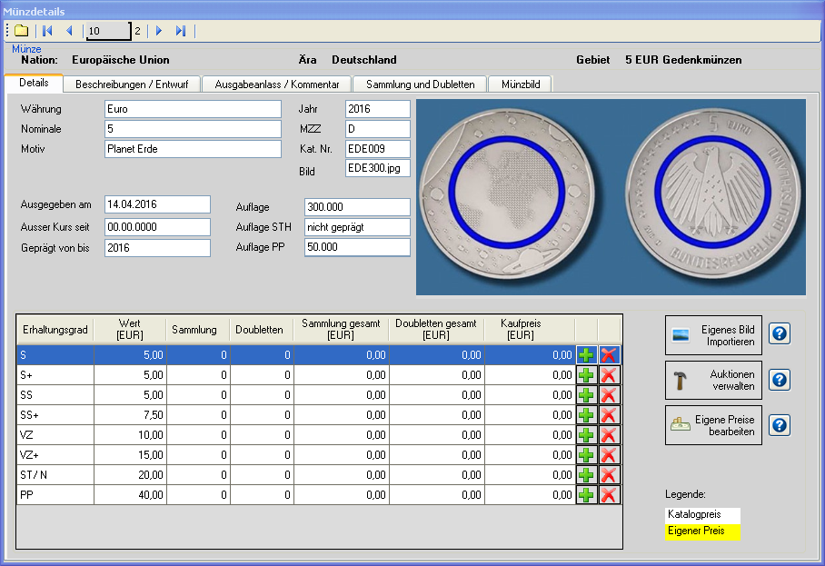

Here can you see the details of the selected coin from the Coinbook catalog and collect and edit your collection data.

Function of the toolbar

|  |  |
| --- | --- |
|  | Selection of 1 coin |
|  | Selection of the previous coin |
| 10 | Number of selectable coin (pure display) |
| 2 | Serial number of the current coin (pure display |
|  | Selection of the next coin |
|  | Selection of the last coin |
|  | Close the mask |

It will be shown here initial always the coin, you have selected.

Using the toolbar, you can browse but also your coin here.

In the table the coins in your collection according to the degrees of preservation, divided, appear.

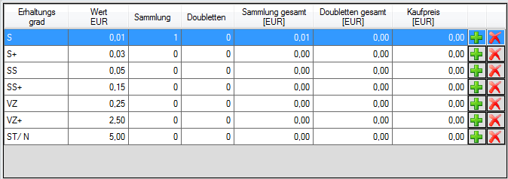

Please note that here the grading ST/H and PP, if they were not marked, does not appear.

|  |  |
| --- | --- |
|  | With this button, you can add new coins. It opens the entry mask for the coins here. See [Add coin](https://ssl.translatoruser.net/bv.aspx?from=de&to=en&a=https%3A%2F%2Fssl.translatoruser.net%2Fbvsandbox.aspx%3F%26dl%3Den%26from%3Dde%26to%3Den%23_Neue_Sammlungsm%C3%BCnzen_und)  To perform this function in the main screen, by selecting the coin in the table and call the function via the menu Edit-> add coin .  Menu-Bearbeiten |
|  | With this button you can remove coins. Also here an extra mask opens then. See [delete coins](https://ssl.translatoruser.net/bv.aspx?from=de&to=en&a=https%3A%2F%2Fssl.translatoruser.net%2Fbvsandbox.aspx%3F%26dl%3Den%26from%3Dde%26to%3Den%23_Sammlungsm%C3%BCnzen_bzw._Doubletten) |
|  | When clicking on this button you can import via a separate mask, your own image for the selected coin.  That will appear instead of the image of the catalog. See [import your own images](https://ssl.translatoruser.net/bv.aspx?from=de&to=en&a=https%3A%2F%2Fssl.translatoruser.net%2Fbvsandbox.aspx%3F%26dl%3Den%26from%3Dde%26to%3Den%23_Eigene_Bilder_importieren.)  To perform this function in the main screen, by selecting the coin in the table and call the function via the menu Edit-> image import .  Menu-Bearbeiten |
|  | When you click the button, you can make, also using a stand-alone mask, notes on auctions for selected coin.  See [Manage auctions](https://ssl.translatoruser.net/bv.aspx?from=de&to=en&a=https%3A%2F%2Fssl.translatoruser.net%2Fbvsandbox.aspx%3F%26dl%3Den%26from%3Dde%26to%3Den%23_Auktionen_verwalten) |
|  | If you believe that may be clicking on the button you can the prices specified by the catalog for the selected coin do not apply to your collection, also via a standalone screen, capture your own price expectations for the coin. See [Edit your own prices](https://ssl.translatoruser.net/bv.aspx?from=de&to=en&a=https%3A%2F%2Fssl.translatoruser.net%2Fbvsandbox.aspx%3F%26dl%3Den%26from%3Dde%26to%3Den%23_Eigene_Preise_bearbeiten) .  You can also run this function in the main mask by selecting the coin in the table and call the function via the menu item ***Edit Edit-> own prices*** .  Menu-Bearbeiten |
|  | Displays help for the button. |

**By the way** : By double clicking on the coin image in the tab tab details will toggle the tab tab ***image*** . Here you will find the image again in a wider view.

Then the following entries from the Coinbook catalog, see the tab tab ***Description/design*** :

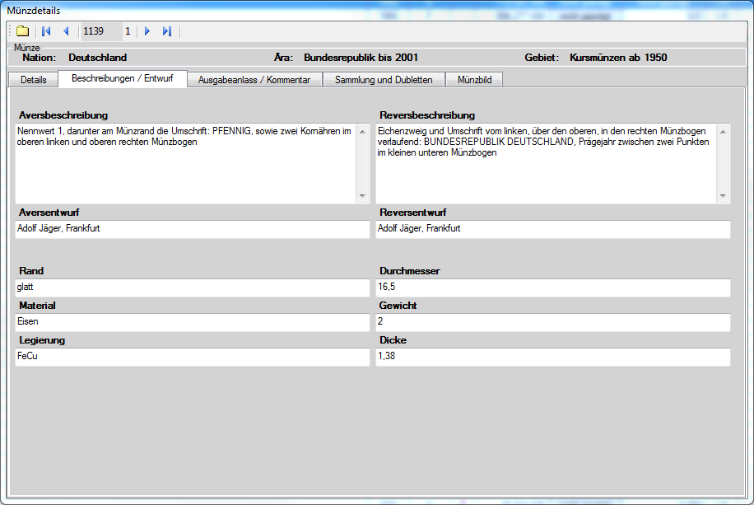

Then the following entries from the Coinbook catalog, see the tab ***Output rise/comments*** tab:

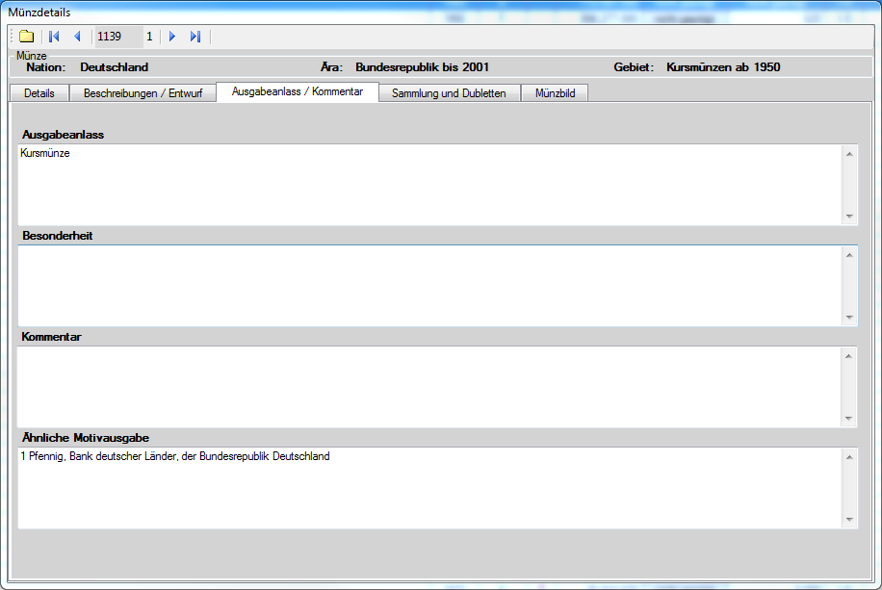

Tab ***collection and duplicates*** , we find tables with the various copies of your collection and your duplicates of the selected coin.

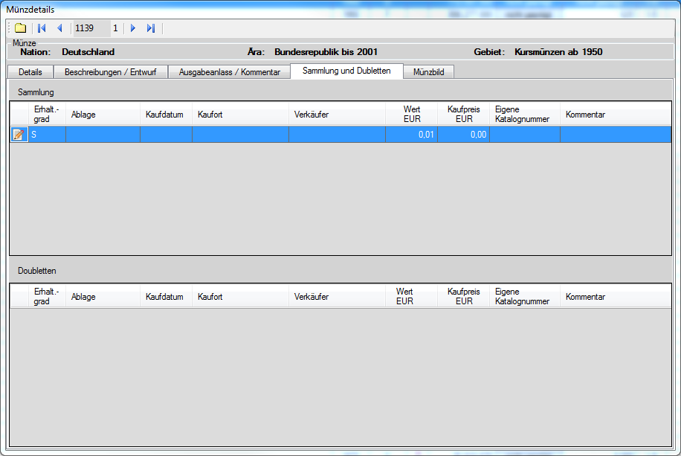

Button  you can correct the entries you have made when adding a coin of collection of or duplicate or supplement (in an edit mask).

The image of the coin in a magnified view, see the tab tab ***image*** .

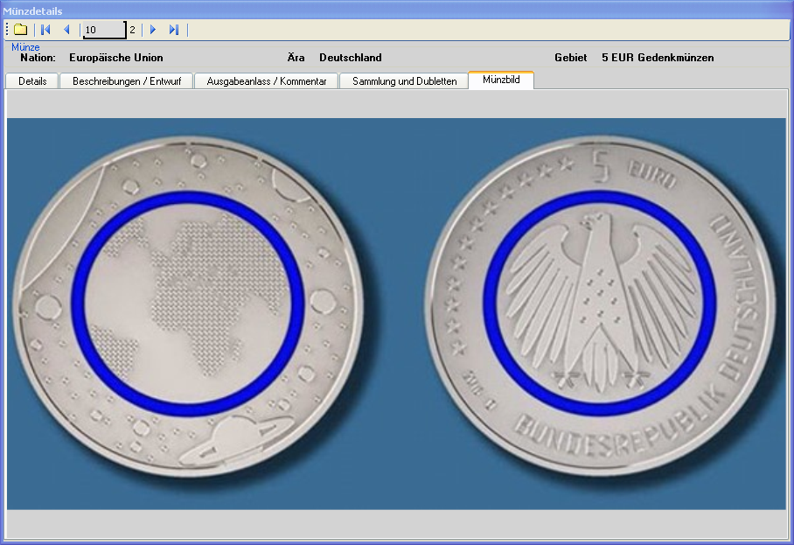

Please note that you can not change Coinbook catalog data or supplement

Should errors are in the catalog data, data about the coin is missing, or you have important or interesting information not captured by us, you tell us please about [support@coinbook.de](mailto:support@coinbook.de)

## Capture collection coins and duplicates

By clicking on the button  calling the input mask for new coins in the coin detail mask:

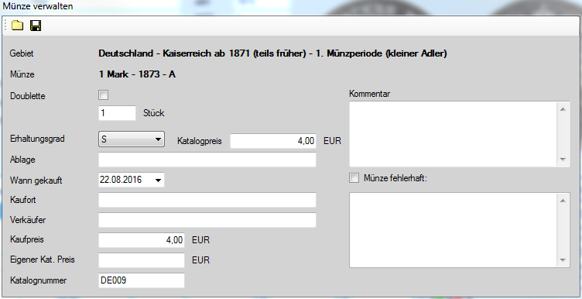

Here you can your new coins, no matter whether record collection or duplicates with all necessary data.

Initial following data are filled out at the call of the mask:

|  |  |
| --- | --- |
| Piece | Default 1 piece, can be increased at any time. If you enter more than 1, a separate data record is created when saving for each coin |
| Degree of conservation | Is the degree of conservation of already filled, in which you the clicked on .The degree of conservation can be changed at any time. |
| Catalog price | The Coinbook catalog price. This field is not mutable |
| Date of purchase | The current date |
| Catalogue number | The Coinbook catalogue number. This field is not mutable |
| Purchase price | If the checkbox ***submit catalog value as the purchase price*** is selected in the settings, then the catalog value is entered here initial |









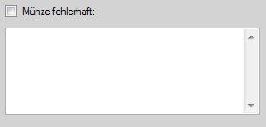

By clicking on the ***store button* ** the new coin is stored.

By clicking on the ***Close button* ** the mask is closed again.

## Delete collection coins or duplicates

By clicking on the button in the collection and duplicate tables, calling the mask to clear of coins:

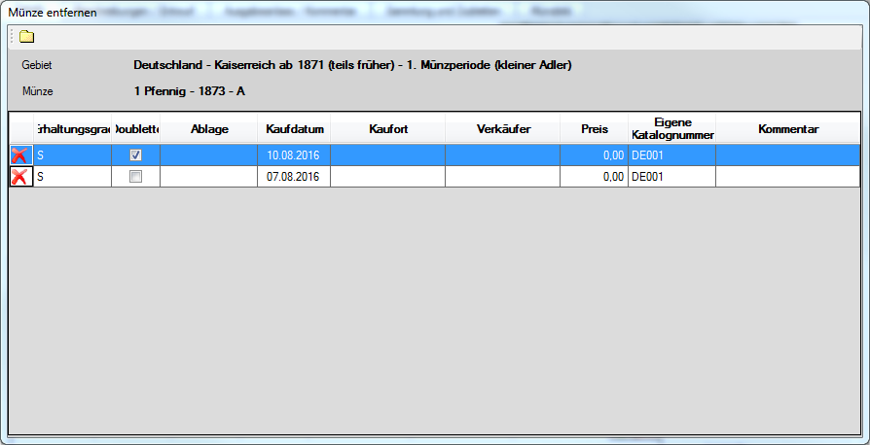

By clicking on the button  in this table, you can delete the individual coins

By clicking on the ***Close button* ** the mask is closed again.

## Edit your own catalog numbers

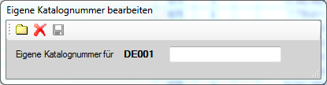

Here you can replace catalog number for the coins our Coinbook by the numbers of other catalogues (E.g. Hunter or beautiful) or of course by your own.

By clicking on the ***store button***  the new catalog number is stored. If no change in the input field was made, this button is inactive.

By clicking on the ***Delete button***  the Coinbook-catalog number is reactivated.

By clicking on the ***Close button* ** the mask is closed again.

## Edit your own prices

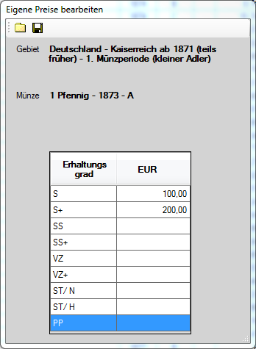

Here you can our Coinbook catalog prices for the coins by Replace prices that seem appropriate to you . If you want to enable the Coinbook prices, you must remove only the appropriate entries from the table

By clicking on the ***Close button* ** the mask is closed again.

By clicking on the ***store button***  prices are stored. If no change is made, this button is inactive.

## Import your own images.

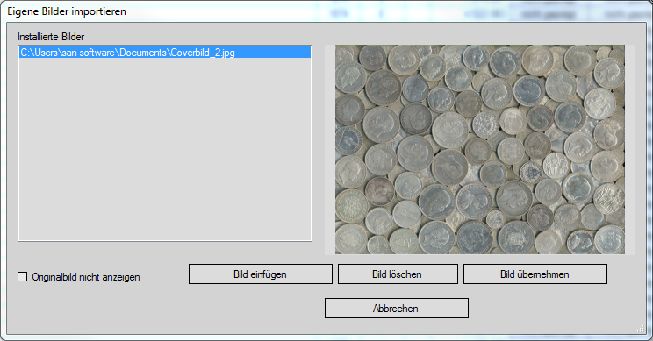

If you want to insert your own image, please click on the button ***Insert Image***. Then the following screen will appear:

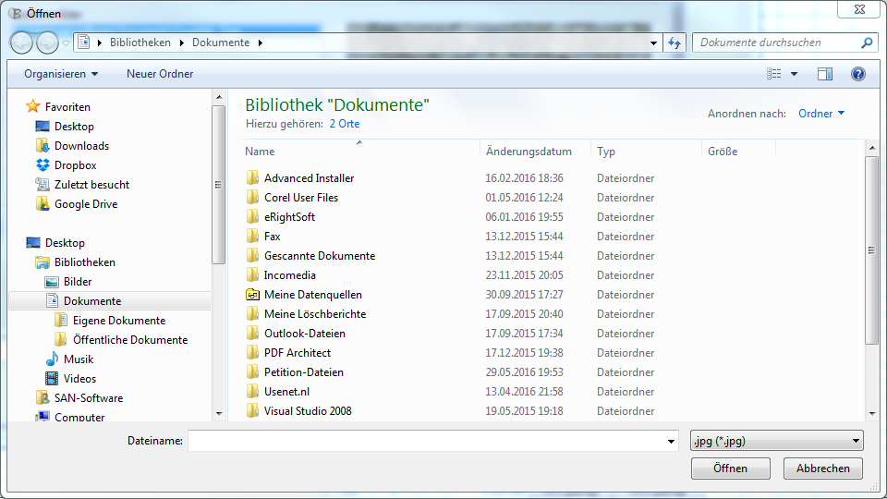

Here you find your picture then. After clicking on the ***Open*** button, the image will appear in the above screen to control. To apply the image in Coinbook then press the ***apply image*** button.

Path and name of the image will appear in the list to the left.

If you want to delete an image, simply select the image in the list and then click ***delete image*** .

The mask is closed by clicking the ***Cancel button*** .

## Manage auctions

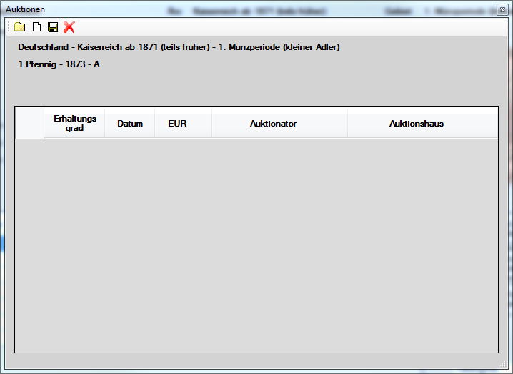

Here you can enter the selected coin auctions.

New acquisition auction click the button ***new*** . It will be a new empty row in the table. Click in the appropriate fields in this row to enter the data.

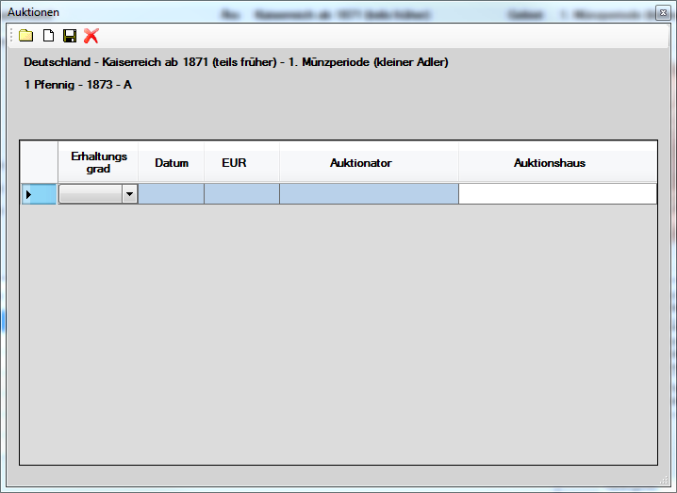

A change of the entries is also by clicking on the appropriate cell and then override.

By clicking on the ***Close button***  the mask is closed again.

By clicking on the ***store button***  the data is stored. If no change is made, this button is inactive.

To delete a record, you mark it by simply clicking on. Then, press the ***delete*** button 

## Settings

**Settings for the overview table:**

There's different kinds of display for your collection. You can define this display mode under the menu item ***Options - settings*** .

Under the ***General*** tab tab you will find the point ***list settings***

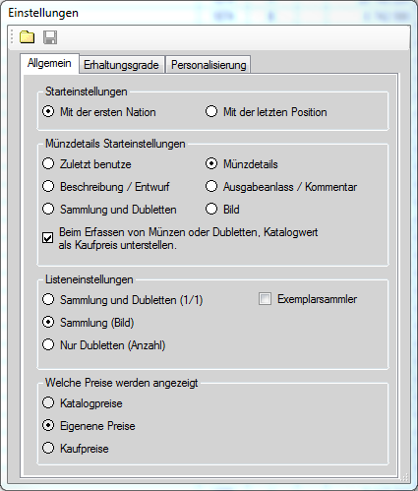

**Collection and duplicates (1/1)**:

The number before the slash is the number of coins in your collection, while the number after the forward slash represents the number of your duplicates.

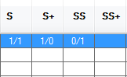

**Image collection:**

Here, no number of coins in the table, but only a characteristic stands whether the coin is in your possession. That is then the symbol  marked.

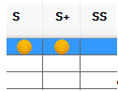

**Only duplicates (number):**

With this setting, only the number of duplicates is entered.

**Copy collectors:**

Still no function.

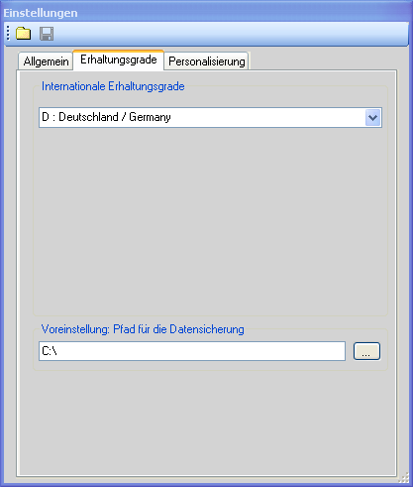

**International grading**

Here, you select the language in which the grading are displayed. The German grading are used by default.

**Default path for the backup**

Here, choose your default setting for the drive and the folder from which are proposed for data backup and data recovery. If necessary, you can change this setting in the area of backup and recovery.

The set default setting you will be offered repeatedly.

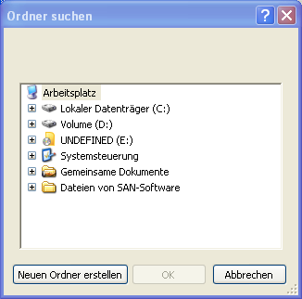

**Personalization**

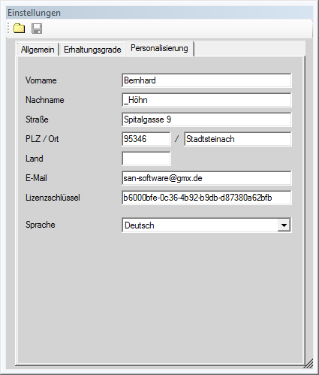

On this tab tab, you can see up your license data.

The only thing is here can be set, is the language of the program interface. See all currently available languages in the combo box.

By clicking on the ***Close button***  the mask is closed again.

By clicking on the ***store button* ** the changes are saved. If no change is made, this button is inactive

## Set courses

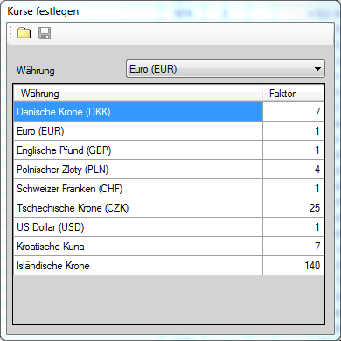

Here you can set the currency in which the catalogue value of the coins is displayed. Currently available here only the listed currencies. You can manually enter the factor for conversion.

By clicking on the ***Close button***  the mask is closed again.

By clicking on the ***store button***  prices are stored. If no change is made, this button is inactive.

## Mints

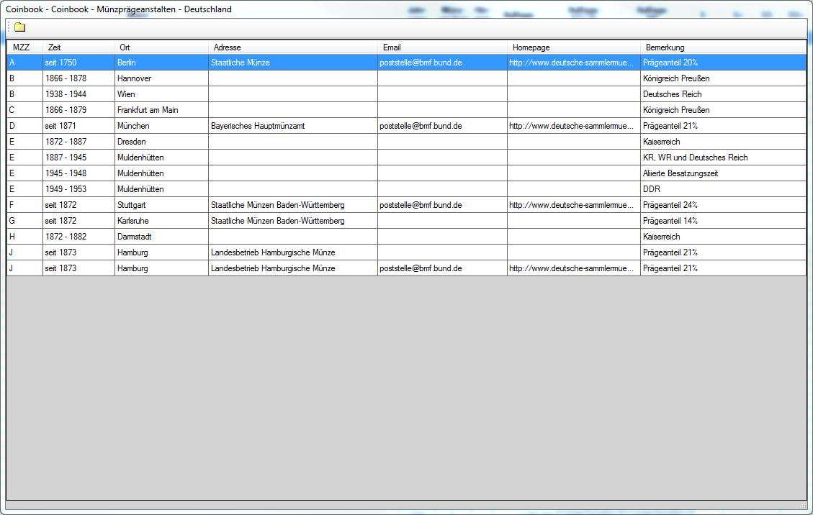

Display the mints of the currently selected module

By clicking on the ***Close button***  the mask is closed again

## State of the database

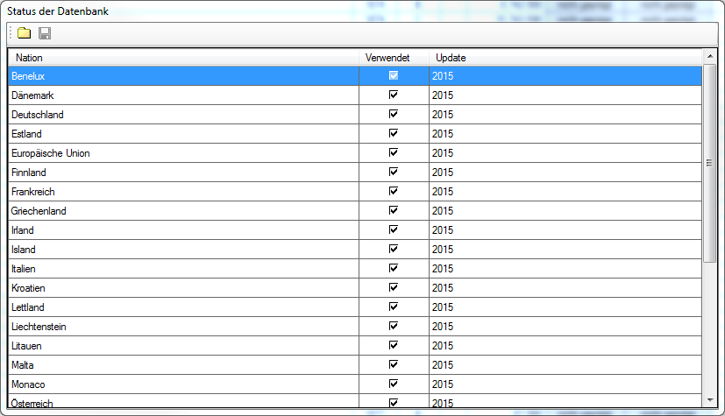

Here you can see all available modules currently in Coinbook.

The hooks used in the column indicates whether you have the module, and under Update, you will see the current version of your module.

By clicking on the ***Close button***  the mask is closed again.

## Manage database

**Backup**

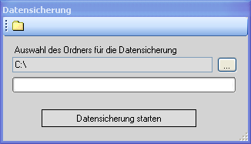

You should perform regularly a backup, to save your data in case of data loss. Please our appendix also refer to [backup](https://ssl.translatoruser.net/bv.aspx?from=de&to=en&a=https%3A%2F%2Fssl.translatoruser.net%2Fbvsandbox.aspx%3F%26dl%3Den%26from%3Dde%26to%3Den%23_Datensicherung_1)

Only the data collected from you will be backed up. The Coinbook catalog will not be backed up, because here time and space would be wasted. The modules can be loaded at any time using the appropriate menu item.

Select button  the location where you want to run your backup, or apply just the proposed adjustment. Then press the button ***Start Backup*** .

Coinbook then tells you when the backup is finished.

By clicking on the ***Close button* ** the mask is then closed.

**Restore data**

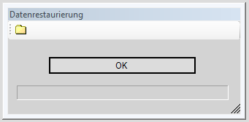

Here you can play a simple back your backed-up data with data loss.

After pressing the ***OK***button to select the location and file name of your backup. Then, press the ***Open*** button.

Coinbook then tells you when the backup is finished.

By clicking on the ***Close button* ** the mask is closed again.

**Repair database**

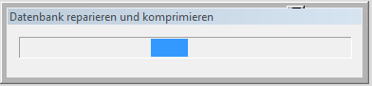

 If you believe that there is something about the database in order, please perform this function.

The mask is automatically closed after the repair.

## Importing CB2006

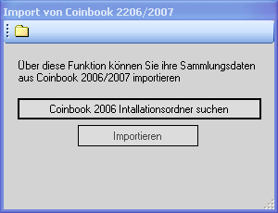

Please search under the button the data folder of old Coinbooks out.

By pressing the button  your old collection data in the Coinbook then imported 3.0

See annex [Import from old versions](https://ssl.translatoruser.net/bv.aspx?from=de&to=en&a=https%3A%2F%2Fssl.translatoruser.net%2Fbvsandbox.aspx%3F%26dl%3Den%26from%3Dde%26to%3Den%23_Anleitung_zum_Import)

By clicking on the ***Close button***   the mask is closed again

## Importing Coinbook 2.x

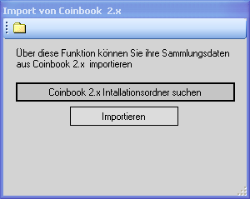

Please search under the button  the data folder of old Coinbooks out.

By pressing the button  your old collection data in the Coinbook then imported 3.0

See annex [Import from old versions](https://ssl.translatoruser.net/bv.aspx?from=de&to=en&a=https%3A%2F%2Fssl.translatoruser.net%2Fbvsandbox.aspx%3F%26dl%3Den%26from%3Dde%26to%3Den%23_Anleitung_zum_Import)

By clicking on the ***Close button***   the mask is closed again

## About the program

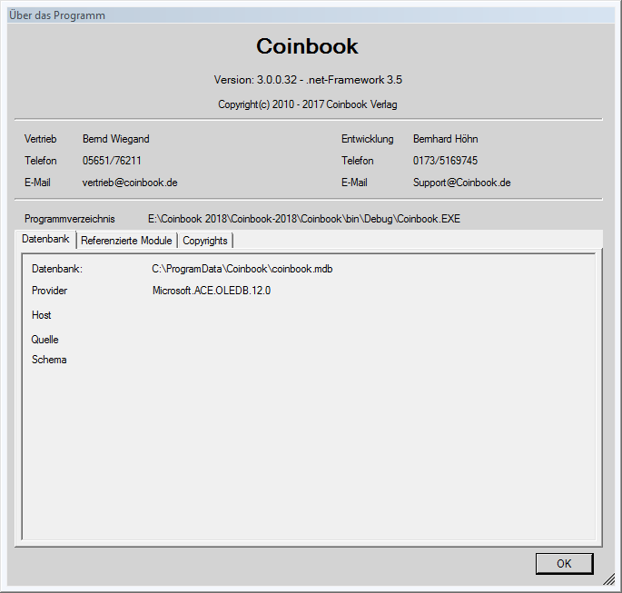

Get some general information about Coinbook

The mask is closed by clicking the ***OK button*** .

## Show Guide (PDF)

Here you can view this guide and also print.

Please keep in mind that this may be a PDF reader must be installed on your PC.

## Show latest news

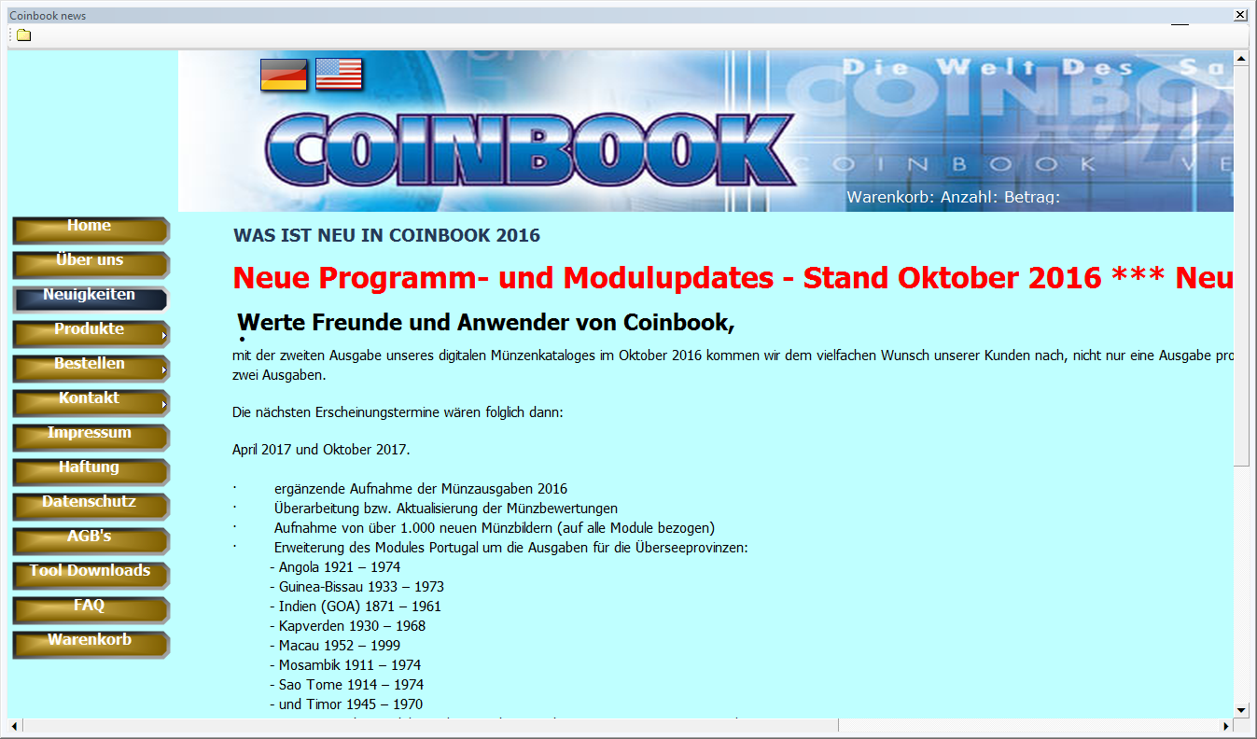

Here you can retrieve directly, our latest news by Coinbook without going via your Internet browser.

## FAQ

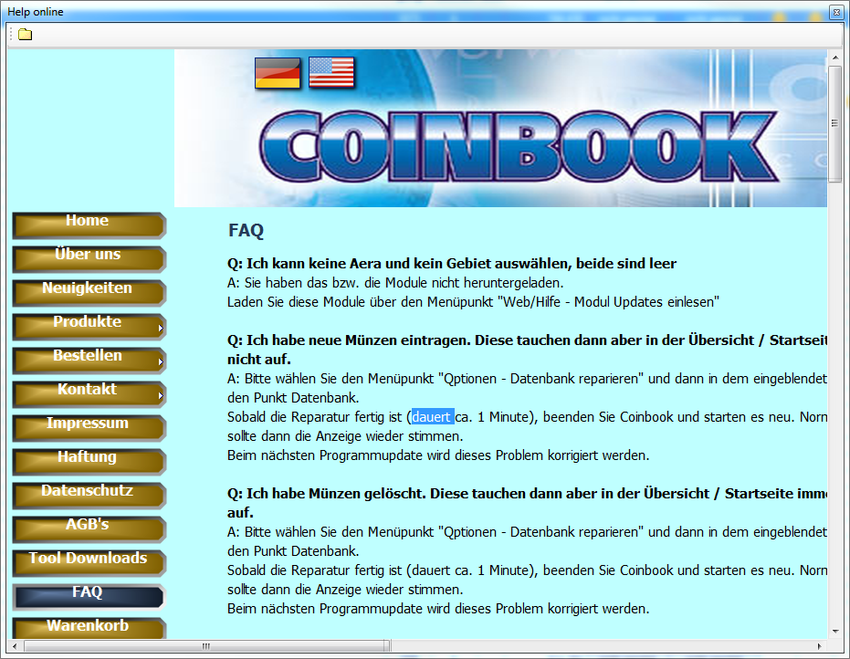

Here you refer to the FAQ page on our Web site.

By clicking on the ***Close button***   the mask is closed again

## Order on the Internet

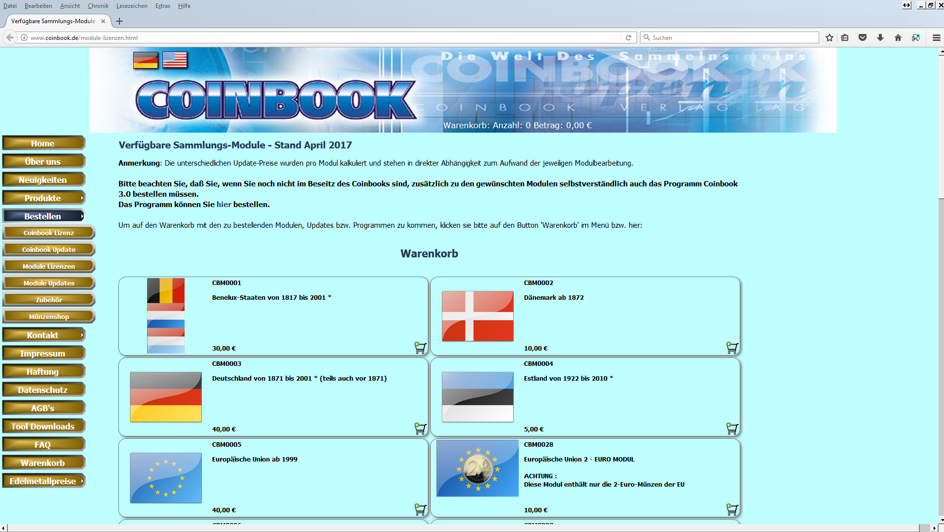

Here you are directed to the order page on our Web site.

## Support

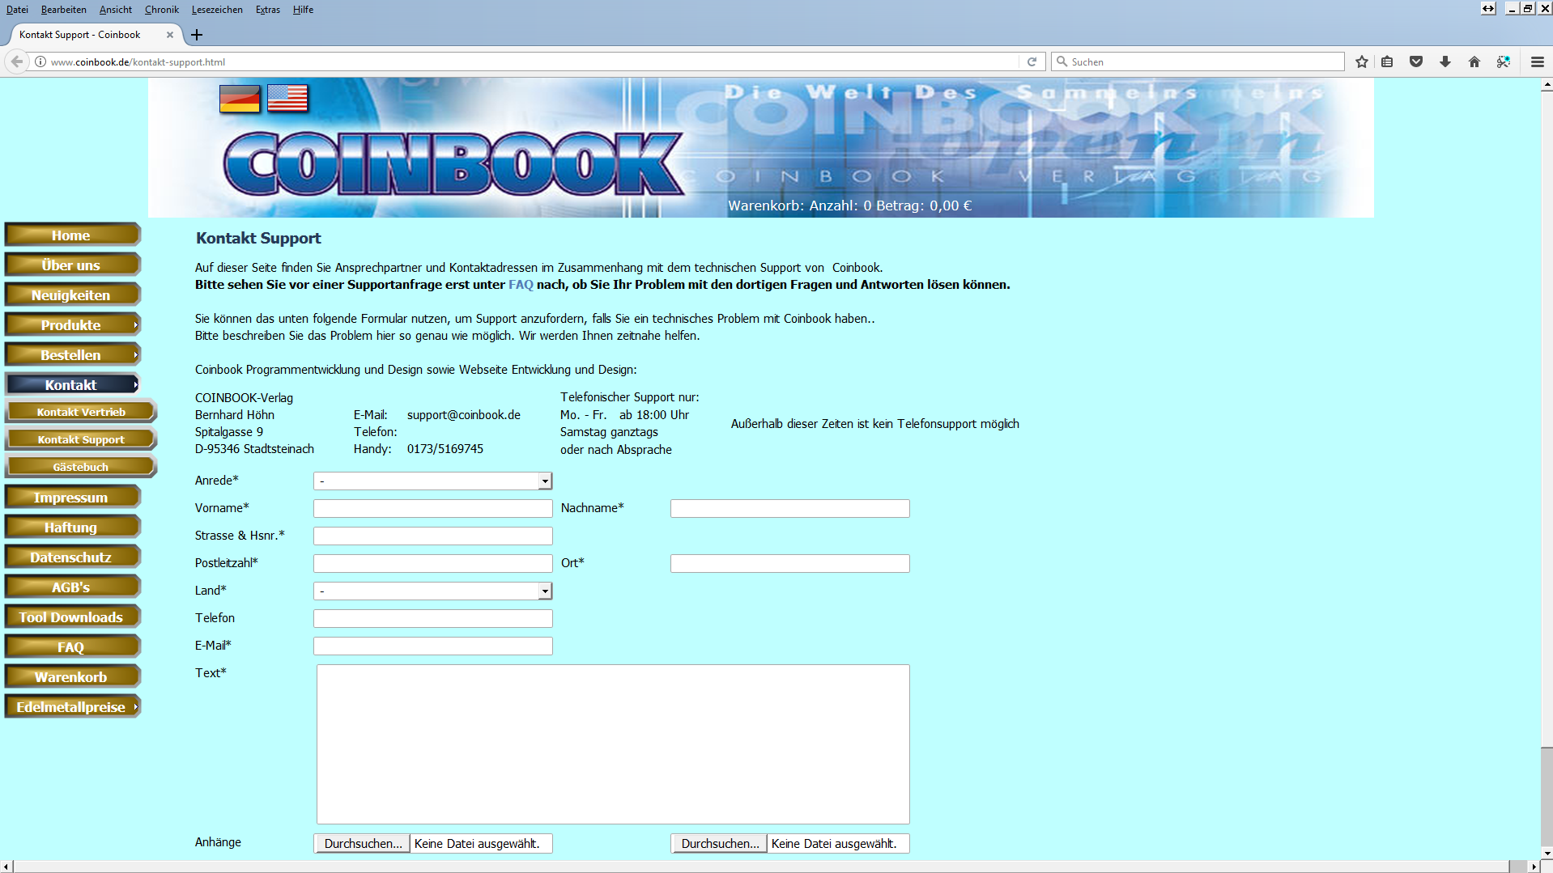

Here you are directed to the support page on our website. On this page, you will receive support if necessary.

## Guestbook

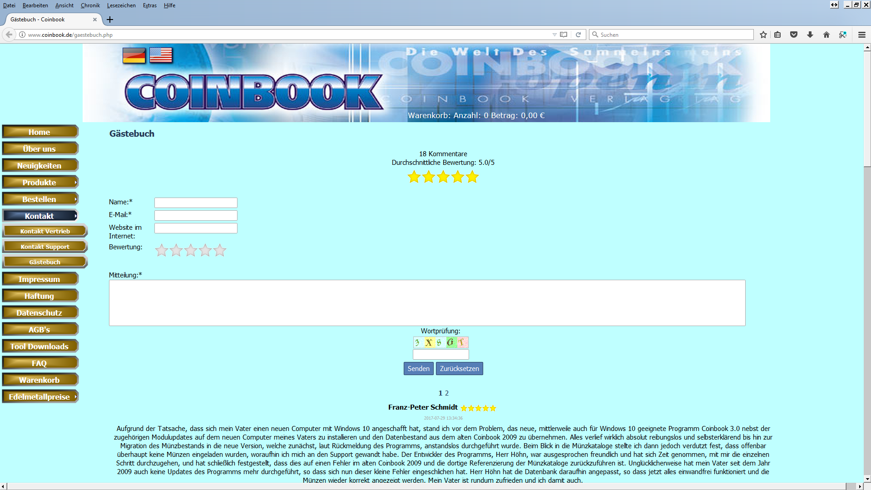

Our Web site includes also a guestbook. Please leave a nice comment here if you are satisfied with Coinbook and our support.

## Purchase new modules

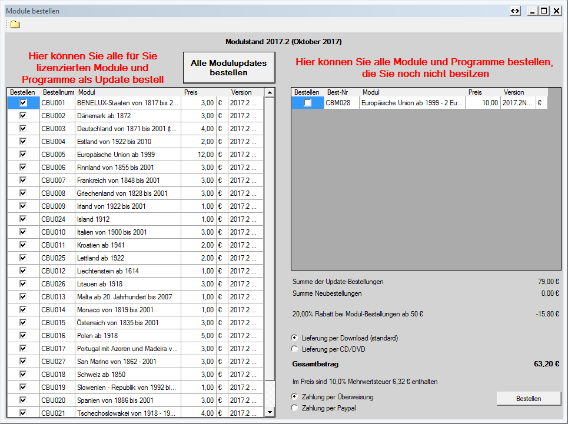

In this window, you can easily order your updates and new modules.

On the left, lists all modules that you have, while the modules are available on the right hand side you have (still) not license.

Click the check box before the respective module that you would like to order. If you would like to order all modules as an update, then click with the mouse on the button



On the left side, you can then see your costs

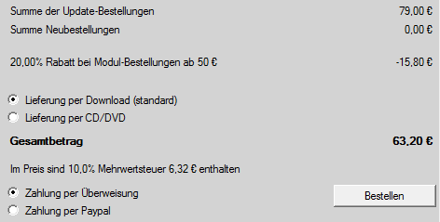

As you can see here, there is a percentage discount for acceptance from a certain amount.

Continue to choose now, whether you get the modules via download, or whether it be shipped via CD to you.

However, the delivery by CD costs a supplementary charge for postage and packaging, as well as of course material costs.

By Coinbook-Verlag, delivery via download as a standard is proposed (as always).

Select the payment by bank transfer or by PayPal on our Web page.

You can make any changes to your order, until you the button

 pressed.

You will be switched to the following page:

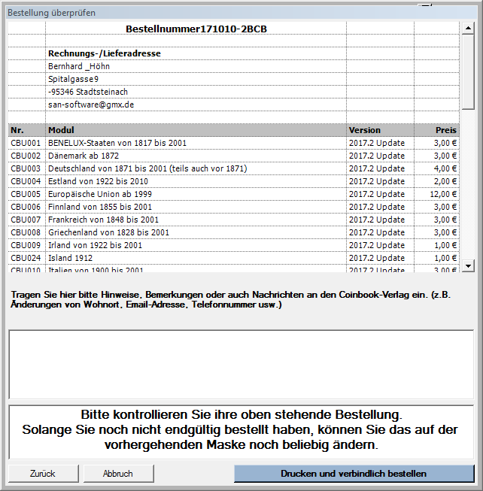

Get an accurate view once again about your order. In addition, you can send us a message here.

If you then  click on, then the order will be sent automatically and permanently. At the same time, the order will be printed out.

## Modul Updates

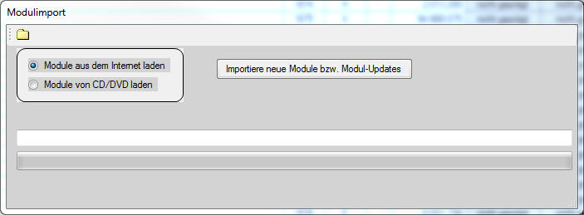

If you new modules, or Engine updates have ordered must load the new data about this mask after our release of this module in your Coinbook.

Here, you must select whether you download the modules from the Internet, or whether you have received it via CD, or DVD.

Next, click on.

If you download from the Internet, download and the Impaort starts now.

If you have selected CD or DVD you must select your CD or DVD drive now in the following form:

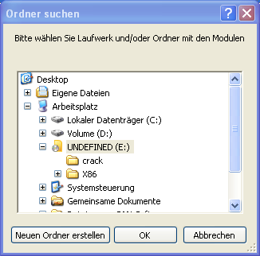

Follow the download and installation process in the lower half of the screen.

## Updating the Programms

Coinbook checks each time, whether there is a new update of the programme. If Yes, the following message appears.

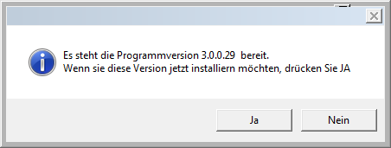

If you click on Yes or later on the ***menu point program update download***, or click the icon  click in the toolbar, then the following screen will appear:

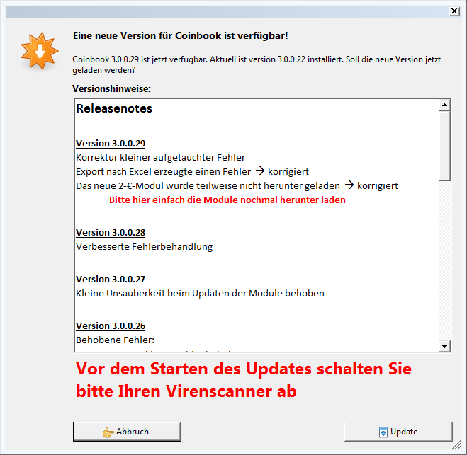

Here you can see which changes, corrections and improvements in the various versions have been made.

If you then click the button ***Update*** , the update is being downloaded.

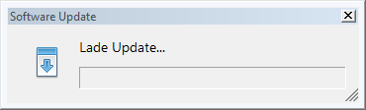

After completing the download, further installation, such as in a new installation of the program is carried out automatically

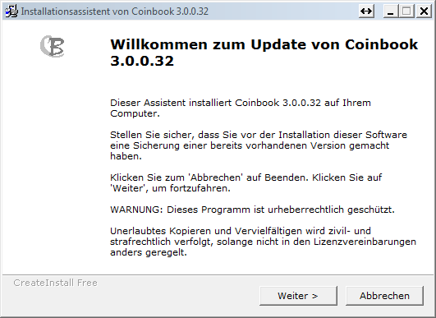

## Program update from CD

Please, select the drive on which the program update is.

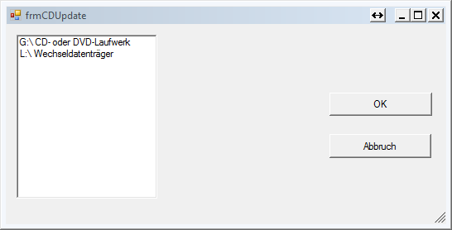

## Teamviewer

By clicking on the icon  or by selecting the corresponding menu item, you can start from Coinbook, the supplied TeamViewer. Our support can break, if necessary, a remote maintenance of the program.

## Language settings

Coinbook can be set to different languages. Following languages are currently available:

- German (standard)

- English

You can set the desired language during installation or during the program run through the combo box  Toggle the toolbar.

Thus, the UI language and all descriptions of the coins on the appropriate language will be converted. This process can take up to several minutes depending on the amount of your purchased modules.

The history of the language change will be shown in the window.

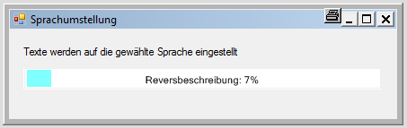

## Screen magnifier

**Function of magnifying glass**

The Magnifier is the magnification of a subarea of the Coinbook window, the mouse cursor.

The Magnifier can screen magnifier menu or the icon  be switched off.

You can move the **screen magnifier** on any any place on your screen.

To go with the mouse pointer on the title bar of the window of Magnifier, press the left mouse button, hold it and move the mouse to the desired position of the screen. The window moves with the mouse cursor with.

Then simply release the left mouse button on the target position.

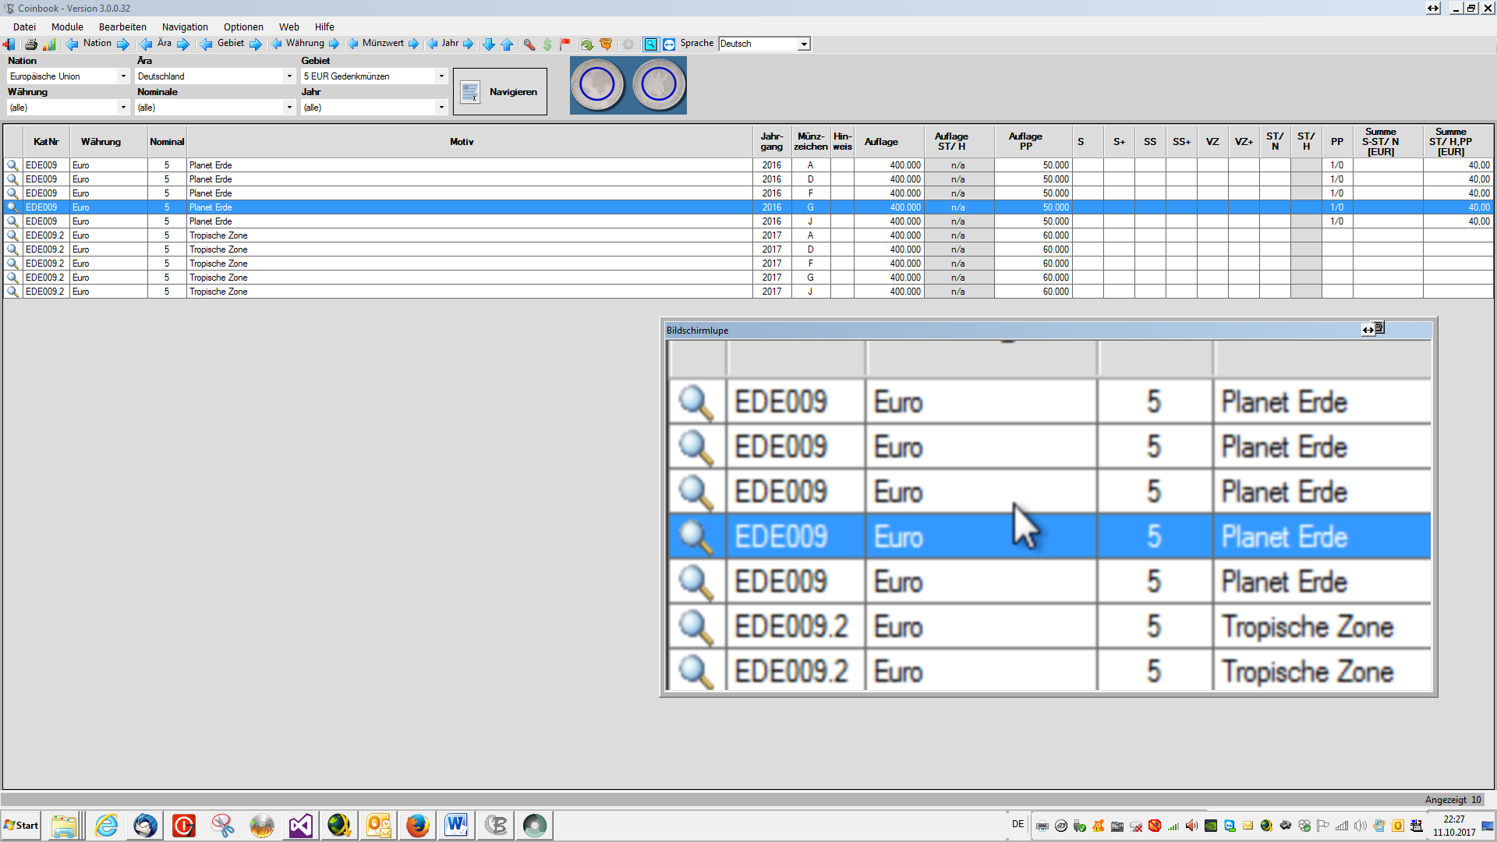

**Settings**

Here you can set basic settings for the screen magnifier.

With the sliders

 you can set size and zoom level of the Loupe. Just move the pointer of the corresponding slider with the mouse while holding down the left mouse button

If you click on the checkbox **Remember last position** then Magnifier remembers the last position.

If you click **maintain aspect ratio** , the width is when adjusting the height and adjusted automatically when adjusting the width.

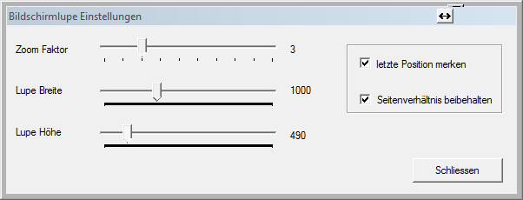

## Output

The following menu line is located in any of the statistics



with the following functions:

|  |  |
| --- | --- |
|  | Close the window |
|  | Expression of the statistics on the printer |
|  | Output of statistics into a PDF file |
|  | Output of statistics to Excel |
|  | Output of statistics to Word |
|  | Output of statistics to a CSV file |

**Calculate values of collection**

The number of coins in the degrees of preservation, the total number and the total value of the selected collection module are displayed here.

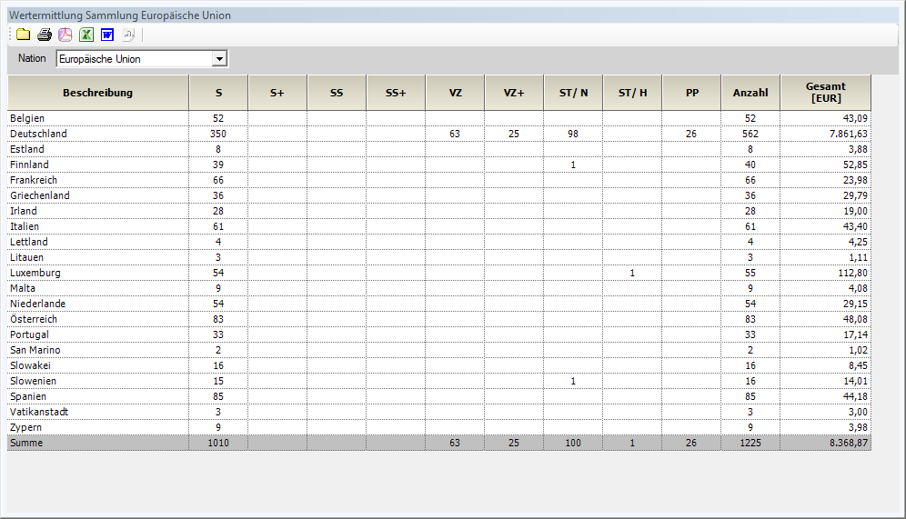

When you select of a collection module, this ad for the individual eras is separated and shown as the sum of the collection module.

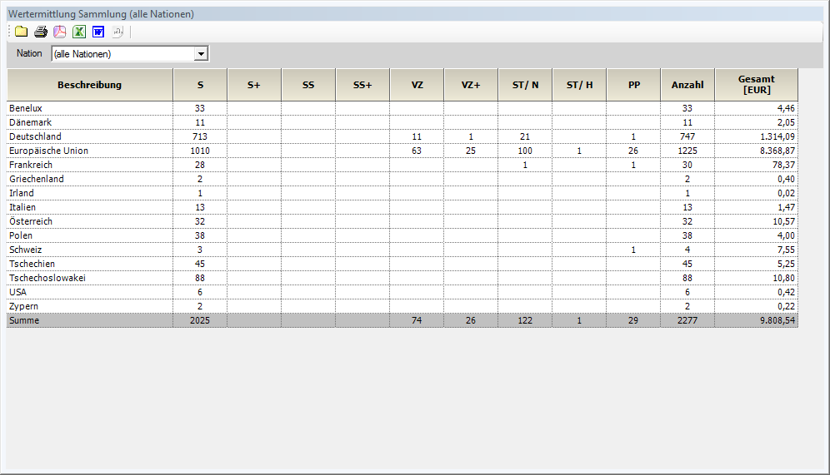

Choosing **All Nations** , this display for each collection module is separated and displayed as the sum for all Nations.

Only coins of the actual collection are displayed. No duplicates.

The value of the coins will be according to the [Settings](https://ssl.translatoruser.net/bv.aspx?from=de&to=en&a=https%3A%2F%2Fssl.translatoruser.net%2Fbvsandbox.aspx%3F%26dl%3Den%26from%3Dde%26to%3Den%23_Einstellungen_1) calculated

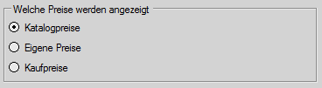

If here marked **Catalog prices** , the value of coins with the catalogue prices of Coinbook is determined.

If **your own prices** has been marked, is to determine of the value of the coins used price, was recorded as its own price.If a coin has no own prize, the price in the cataloque is used here.

The **purchase price** is not taken into account here. If this is selected, the catalog price is automatically used.

**Calculate values of duplicates**

Mutatis mutandis as before, but only for duplicates.

**Reporting collection**

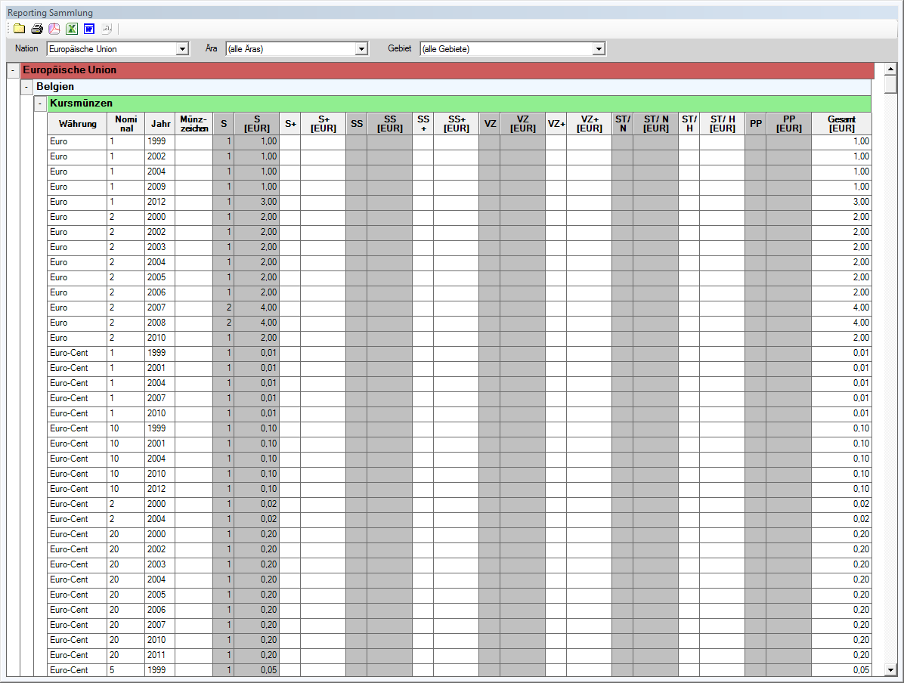

Here, the stocks of individual coins will be issued.

Also here, the choice of collection modules can be as in determining value. In addition, even era and areas can be selected.

Displays only the coins of the actual collection.

**Reporting duplicates**

As above, but only for duplicates.

**Reporting error lists**

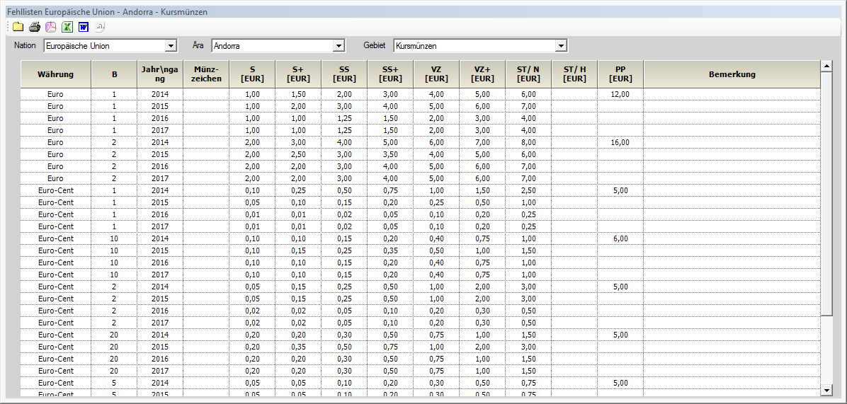

Here, all the coins, with the Katatogpreisen of the grading, be printed out of which you have no copy.

Here, too, you can filter by nation, era and area.

**Costing collection**

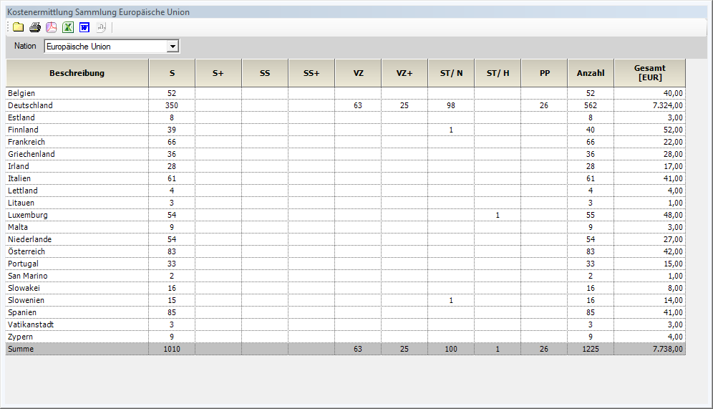

Mutatis mutandis as at the valuation, but be as prices registered purchase price used by you.

# Appendix

Useful descriptions in the annex.

## Backup

**Why a backup?**

You should not only ask themselves this question. If your data is important to you, you should make sure that any loss of data (hard disk faulty, computer defect, or only database broken or deleted, etc.) Your data copy are available, and then at any time with little effort can be restored.

**What are the backup?**

Various storage media such as hard drives, optical discs or Flash memory have all their pros and cons. Therefore, it makes little sense to prefer a medium to the other. However, it is not a good idea to leave; only on a storage medium It is advisable the backups of your most important data at various places to be kept. Since all storage media failure can and you can also make mistakes as a user.

In principle, a backup should be on an external storage device. E.G. USB stick, external hard drive, etc.

Also a backup in the cloud is possible. Providers such as **dropbox** and **Google** offer it free a sufficient disk space...

An internal hard drive should not be used here, because in case circumstances, no way exists to access the backup or the backup is also destroyed.

**How to secure?**

Under **Options - backup** to create a backup of your collection data.

You must select only drive and folder in which to save the backup. Everything else makes the program.

Always a complete backup of your collection data is made.

The backup Gets the name **Coinbook-backup -** and the date in the form **YYYYMMDD** and the **.zip** extension (for example **Coinbook Backup20160503.zip**) on which the backup was created. This is

* prevents an old backup will be overwritten accidentally.
* also the temporal level of backup without any extra effort can be seen.

A rotating backup with 3 disks here want to make:

* Backup to disk 1
* Backup to disk 2
* Backup to disk 3
* Backup to disk 1

etc.

**Storage backup**

The backup media should be connected only to the data backup or restoration to the computer, to avoid that it is also damaged in a computer crash.

**When and how often should be secured?**

In principle, it doesn't matter. It is only important that you need to control your backup behavior itself. Just keep in mind that you have always the work with data loss, to collect the missing data, if your backup is not current.

Then of course, if you recapture any data, but only "look", or print reports no backup is necessary.

**Recommendation:**

According to our cheapest and easiest solution for the backups of your collections is a combination of 3 USB drives here. The storage capacity can lie in the low range, because a backup even when very large collections requires very little storage space.

A storage capacity of 1 to 2 GB per stick is more than sufficient, as long as that collection to back up only your Coinbook for your Coinbook backups.

A cheap variant if needed, on our Web page can [www.Coinbook.de](https://ssl.translatoruser.net/bv.aspx?from=de&to=en&a=http%3A%2F%2Fwww.coinbook.de%2F) under Accessories order.

## Instructions to import of your collection from a previous version.

**1.** Select the menu item in the Coinbook **Options - import from Coinbook 2.x**

**2.** Then, in the window that opens, click on **Coinbook 2.x installation folder search**

**3.** Locate the folder in which their data from Coinbook 2.x are here  
  
**For Windows Vista/7/8/10 the data usually below:***Bibliotheken\Dokumente\Coinbook\Database\Data*or possibly:  
*Bibliotheken\Dokumente\Dokumente\Coinbook\Database\Data***In Windows XP, you will find the data usually below:**C:\Programme\Coinbook*Database\Data****If you have an installation of Coinbook, that is different from the default, you must either know the location of the data, or find it using the search function of Windows can be.****The file you need to look for is****User.dat****.*

**4. After this selection please click on import.**

If you then run a green bar, Coinbook found the old data and takes over.

Then, under certain circumstances, you must stop Coinbook and new calling:

After completion of the import your collection data should be registered.

# Notizen